**PRACTICE NURSE** Our Practice Nurse is available by appointment to carry out general health checks for all long term conditions such e.g. **asthma, diabet**es, **chronic obstructive pulmonary disease (COPD)** and hypertension. She also undertakes various services such as wound dressing, removal of stitches, ear syringing (after seeing a GP), dealing with minor injuries, nebulizer therapy. She is available for routine as well as travel vaccinations and advice which requires a travel questionnaire form to be completed.

**CHAPERONE** The practice operates a Chaperone service. Please ask the clinician at the start of your consultation if want a Chaperone present

**WELL BABY CLINIC** The practice hold designated session for the immunisation of children by our Practice Nurse. Dr Mehta and Dr Stera carry out baby 6 week checks. Pre-School boosters are as important as baby injections and these are done by our Practice Nurse.

**WELL WOMAN CLINIC** service is provided by Dr Stera and our Practice Nurse by appointment. Smear tests and advice on Family Planning and Hormone Replacement Therapy are given

**MATERNITY CARE** Both Dr Mehta and Dr Stera hold a Post-natal booking in clinic.

**WELL WOMAN** We advise all women between 25 and 65 years of age and those on the contraceptive pill to have a **cervical smear** every 3/5 years. All women should regularly check their breasts, please see our Well Woman Nurse if you are unsure how to do this.

**EMERGENCY CONTRACEPTION** The “morning after” pill is effective for up to 72 hours after you have been at risk. An appointment with the Doctor is required if you wish to discuss it in detail or require a prescription. Nowadays emergency contraception tablets are available from a pharmacy without prescription.

**MINOR SURGERY** Minor Surgery is performed by Dr Mehta by appointment.

**Parkview**

**Surgery**

60 West Drayton Road

Hillingdon

UB8 3LA

**Tel:** 020 8573 7674

**Email:** [hillccg.parkview@nhs.net](mailto:hillccg.parkview@nhs.net)

[www.parkviewsurgeryhillingdon.nhs.uk](http://www.parkviewsurgeryhillingdon.nhs.uk)

**Information Leaflet**

**Nov 2020**

|  |  |
| --- | --- |
| **General Practitioners:** | Dr A Mehta – (Male)  Dr H Stera – (Female)  Dr A Damani |
| **Practice Manager:**  **ANP:** | A Badu  P Sutharan |
| **Practice Nurse:** | D Hunt , T Ruwoko & C Denu |
| **Healthcare Assistant:** | T Singham |
| **Administrator:** | S Singhrao |
| **Reception Admin:** | A Tregear, L Pearce, S McLean  S Ellis, L Fung, P Anderson |

**NEW PATIENTS’ REGISTRATION** Please pick up a new patient registration form from our reception. Please read the form careful and complete all the requested information. Incomplete information will delay the registration process.

When your registration is complete you will be contacted for a New Patient Medical so it is important you provide an up to date contact details.

**The** **e-Consult link** can be found on our website. In the comfort of your home 24/7, you can request for appointments, prescriptions, sick note (ideally you will have had a previous contact with a clinician) and other admin matters. You do **NOT** have to queue up on the phone.

**PRESCRIPTION REQUEST We** do not take Repeat prescription requests over the phone. All requests must be in writing. **PLEASE ALLOW 48 HOURS**. All patients are to register to use our Online Service for requesting prescriptions.

* All issue prescriptions are sent electronically and can be collected by giving your NHS number at any Chemist in the UK.
* The Printing of **GREEN script has stopped as of September 2020**
* The Practice is reducing the number of paper script requests
* Contact the practice for our Online Patient Access form

**SPECIMENS** Urine samples should be delivered to the surgery before 10.30 a.m. with the relevant form, name, date of birth, date and time and when specimen taken is on the container. Please state the type of specimen on the label! Stool samples should be taken to the hospital.

**ACCESSING YOUR RECORDS** You have a right to access the information we hold about you, and if you would like to access this information, you will need to complete a Subject Access Request (SAR). Please ask at reception for a SAR form and you will be given further information. Furthermore, should you identify any inaccuracies, you have a right to have the inaccurate data corrected. We aim to process SAR in a month. The practice will endeavour to process urgent request soon where feasible.

**SUGGESTIONS AND COMPLAINTS** If you have any comments on how our service may be improved please put comments in writing to the Practice Manager. If you are dissatisfied with any of the advice or services provided by the surgery please contact the Practice Manager to discuss the matter so that any misunderstandings can be speedily resolve. The practice does have a formal complaints procedure please ask for our complaint procedure leaflet.

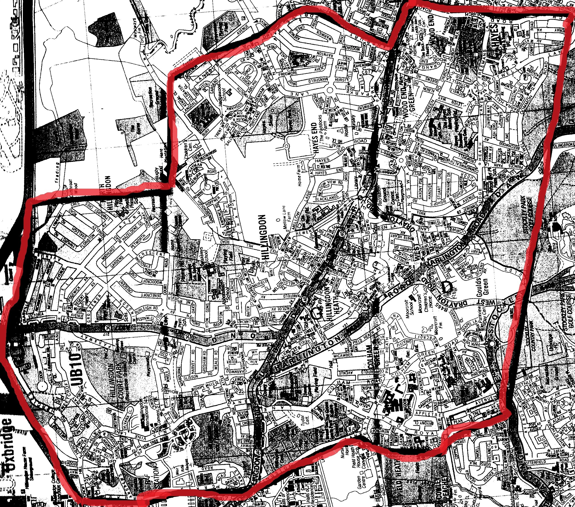

**The Practice Catchment**

**Area**